**Fast fingers**

*A*

*Mini Project Report*

*Submitted in partial fulfilment of the*

*Requirements for the award of the Degree of*

**BACHELOR OF ENGINEERING**

IN

**INFORMATION TECHNOLOGY**

By

**<B.SAIKUMARREDDY><1602-19-737-094>**

**<AKHIL><1602-19-737-064>**



**Department of Information Technology**

**Vasavi College of Engineering (Autonomous)**

**(Affiliated to Osmania University)**

**Ibrahimbagh, Hyderabad-31**

**2020**

**Vasavi College of Engineering (Autonomous)**

**(Affiliated to Osmania University)**

**Hyderabad-500 031**

**Department of Information Technology**



**DECLARATION BY THE CANDIDATE**

**I, B.sai kumar reddy,** bearing hall ticket number, **1602-19-737-094**, hereby declare that the project report entitled **Fast fingers** Department of Information Technology, Vasavi College of Engineering, Hyderabad, is submitted in partial fulfilment of the requirement for the award of the degree of **Bachelor of Engineering** in **Information Technology**

This is a record of bonafide work carried out by me and the results embodied in this project report have not been submitted to any other university or institute for the award of any other degree or diploma.

**B.sai kumar Reddy**

**1602-19-737-094**

(Faculty In-Charge) (Head,Dept of IT)

**Vasavi College of Engineering (Autonomous)**

**(Affiliated to Osmania University)**

**Hyderabad-500 031**

**Department of Information Technology**



**DECLARATION BY THE CANDIDATE**

**I, Akhil,** bearing hall ticket number, **1602-19-737-064**, hereby declare that the project report entitled **Fast fingers** Department of Information Technology, Vasavi College of Engineering, Hyderabad, is submitted in partial fulfilment of the requirement for the award of the degree of **Bachelor of Engineering** in **Information Technology**

This is a record of bonafide work carried out by me and the results embodied in this project report have not been submitted to any other university or institute for the award of any other degree or diploma.

**Akhil**

**1602-19-737-094**

(Faculty In-Charge) (Head,Dept of IT)

**ACKNOWLEDGEMENT**

I would like to take this opportunity and thank everyone who have helped me in completing this project.

First of all I would like to express my special thanks of gratitude to our faculty in-charge D. Prasanna as well as our Hod who guided us along the project in doing the project in an appropriate manner and also gave me the golden opportunity to do this project “**Fast fingers**”.

This helped me in knowing about the various concepts of C Programming Language, which I haven’t known before. It helped me in deliberating why thoughts about the concept and to enhance my skills too.

Secondly, I would also like to thank few websites and you tube channels which I visited when I was doing my project .They have really taught me know the amazing program skills where you can make your project more flexible with many possible use cases.

**ABSTRACT**

Usually people use their pointers to hit one key at a time and spell out words and punctuation. This has also been called the “Hunt and Peck” method. Alternatively, it’s possible to place your whole hands down on the keyboard with fingers resting lightly on the A, S, D, F and ;, J, K, L keys, and thumbs hovering over the space bar. So,our project will enhance the users to approach this touch typing that it also gives a certain amount of beginner knowledge so users type the right keys with the right fingers. users feel comfortable while typing and they can execute them at top speed and users can also practice on programming

Laguages. Lastly, they do it without looking down at the keyboard!

**TABLE OF CONTENTS**

1. **Introduction………………...............................................5**
   1. Objective………………………………………..5
2. **Technology………………………………………………6**

2.1 Software Requirements…………………………6

2.2 Hardware Requirements……………………6

1. **Proposed Work…………………………………………7**

3.1Design………………………………………………..7

3.1.1 Use Case Diagrams………………7

3.2 Implementation…………………………………….8

3.2.1 GitHub Links……………………………13

3.3Testing………………………………………………14

1. **Results…………………………………………………16**
2. **Additional Knowledge Acquired………………………23**
3. **Conclusion and Future Work………………………….24**
4. **References…………………………………………….24**

**INTRODUCTION**

One should have good command over touch typing. We are wasting most of our time for picking the letters and typing, this should be strictly avoided. When we are formally taught to type, it’s usually “touch-typing” (which many of us learned in high school). That means being able to type with multiple fingers without looking at the keyboard.

That can be a real struggle for kids who struggle with fine motor skills.It can be hard for them to coordinate both hands on the keyboard while moving one finger at a time to isolate a letter (or their thumb for the space bar). Using the trackpad or mouse poses an added challenge

So,our project will enhance the users to approach this touch typing that it also gives a certain amount of beginner knowledge so users type the right keys with the right fingers

**PROJECT OBJECTIVE**

The objective of the project is to make an application that will enhance the users to approach this touch typing that it also gives a certain amount of beginner knowledge so users type the right keys with the right fingers. users feel comfortable while typing and they can execute them at top speed and users can also practice on programming

Laguages. Lastly, they do it without looking down at the keyboard!

**TECHNOLOGY**

The software and hardware requirements for the project are:

**HARDWARE REQUIRMENTS**

* Processor : Intel (IR) Core(TM) /Ryzen.
* Processor Speed : 250 MHz to 833MHz
* RAM : 512MB to 1024 MB
* Hard Disk : minimum(2GB ) to 30GB
* Standard Input : (QWERT)Key Board
* System Type : 32-bit processing system(can be more)

**SOFTWARE REQUIRMNETS**

* Software **:** gcc compiler
* Language : C Programming Language
* Operating System : Windows XP (or greater version)/Linux
* Web Technologies : Console based project

**DESIGN**

**USE-CASE DIAGRAM**

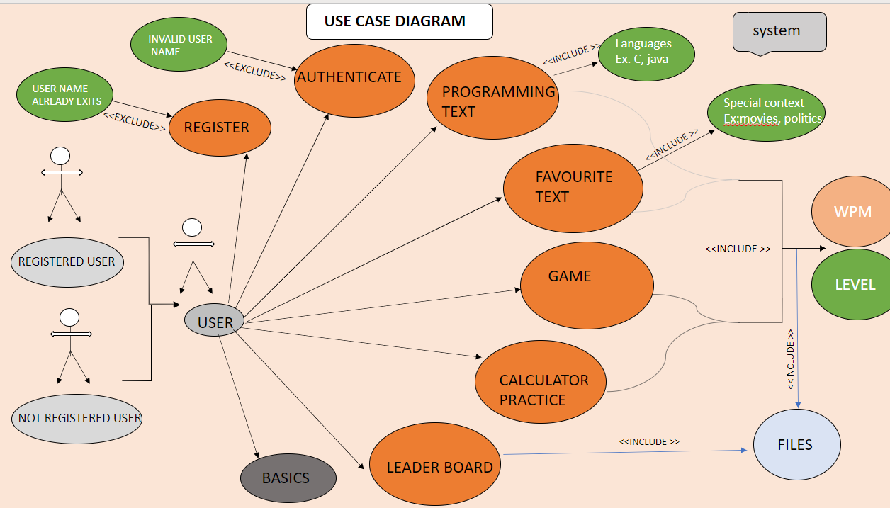

**IMPLEMENTATION**

**USE CASE DESCRIPTION**

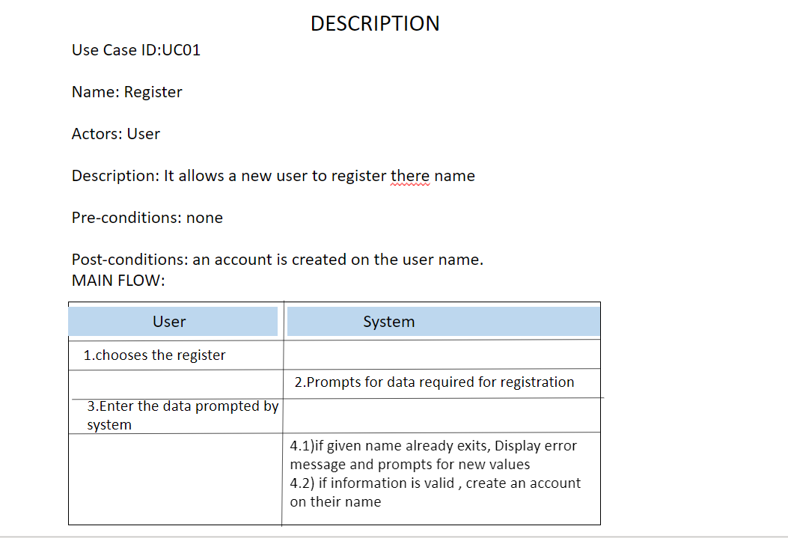

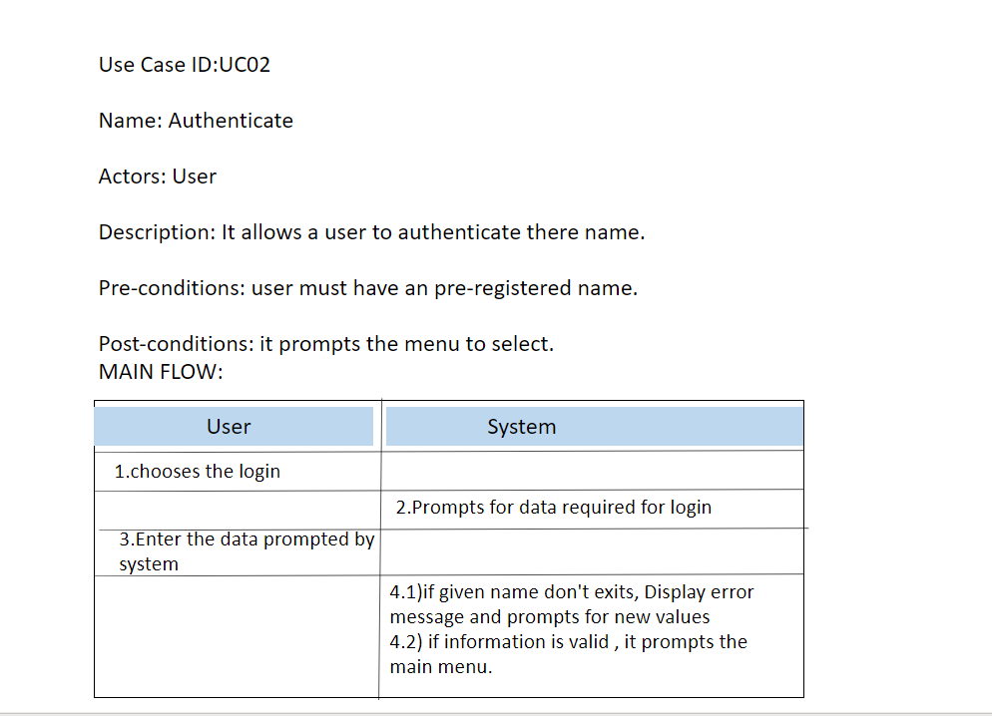

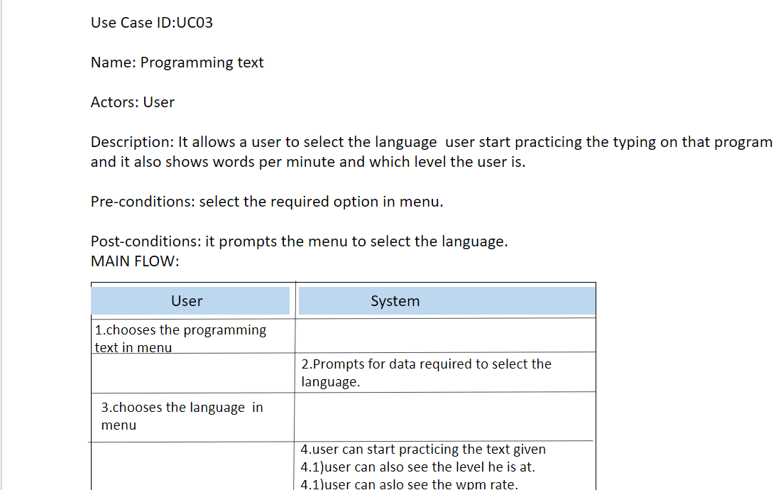

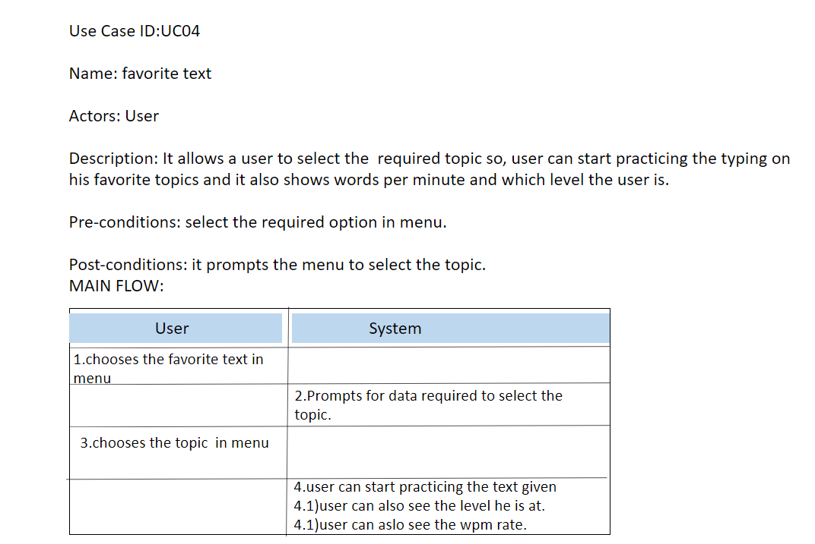

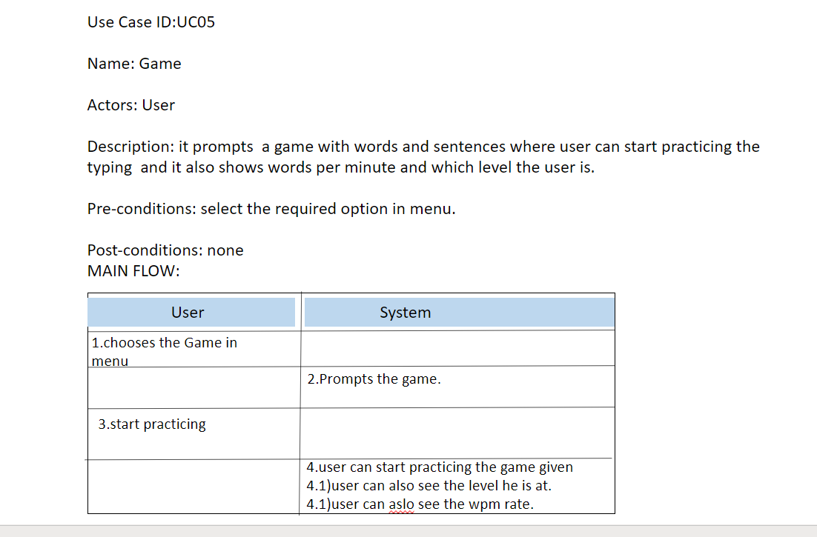

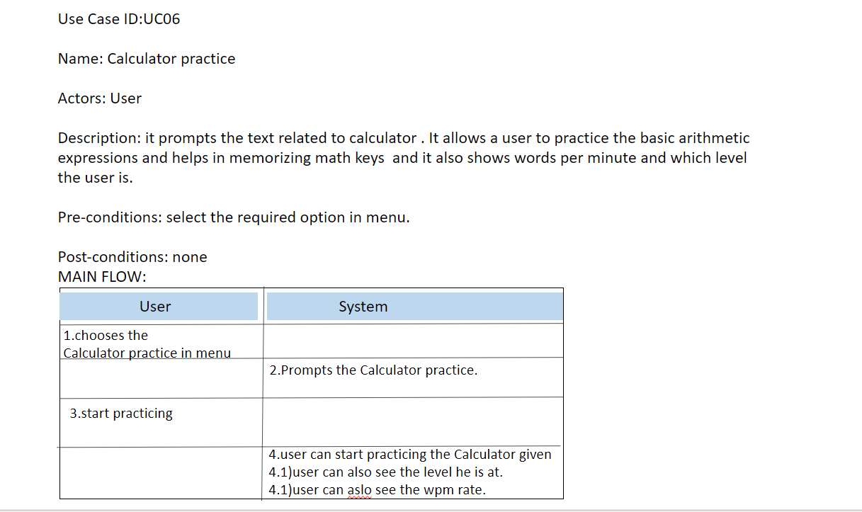

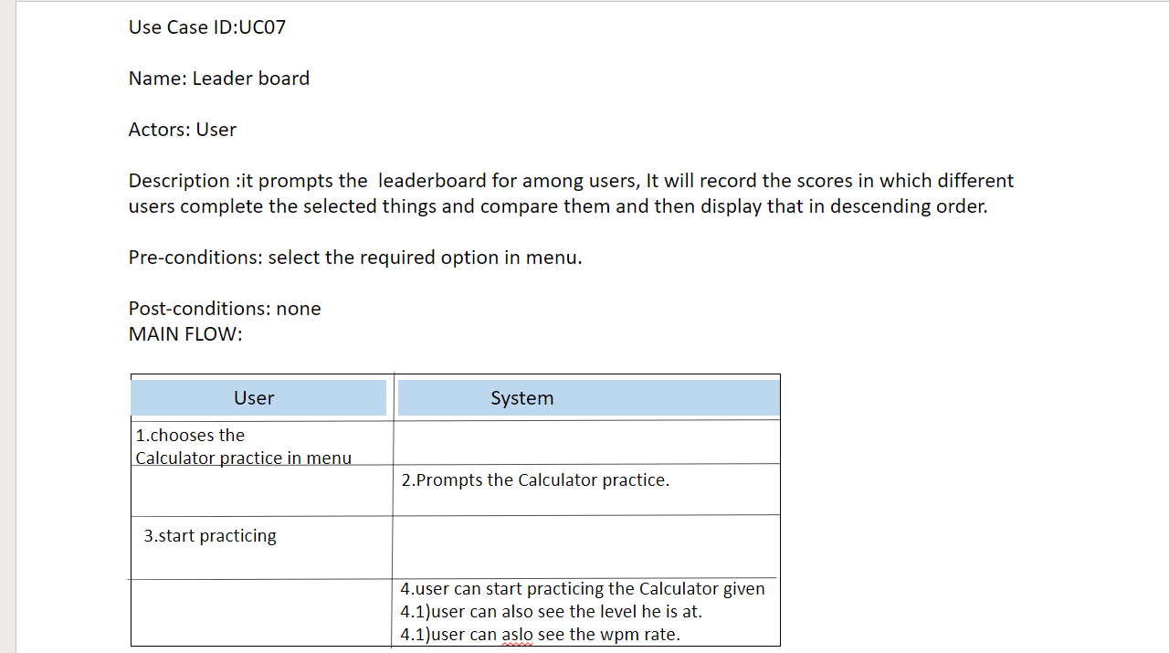

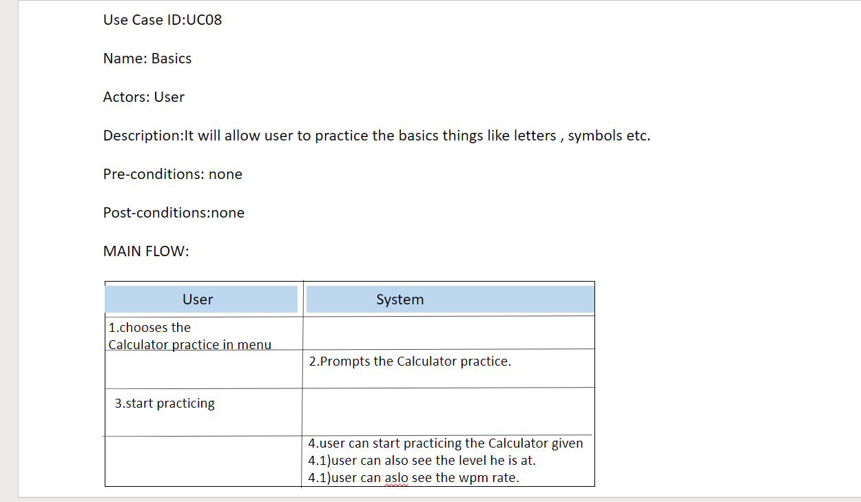

**GITHUB LINKS**

Sai kumar(094):

<https://github.com/saikumarreddybarda>

Akhil(064):

<https://github.com/strange-venom>

**TESTING**

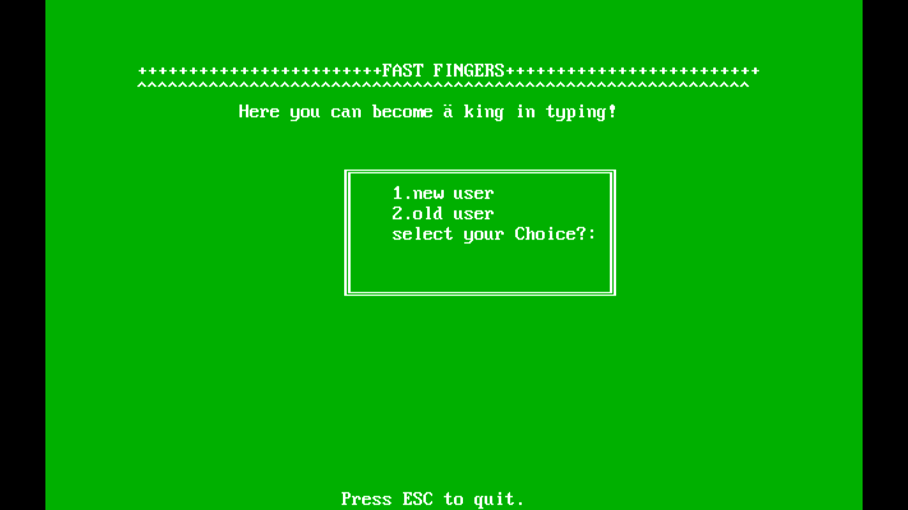

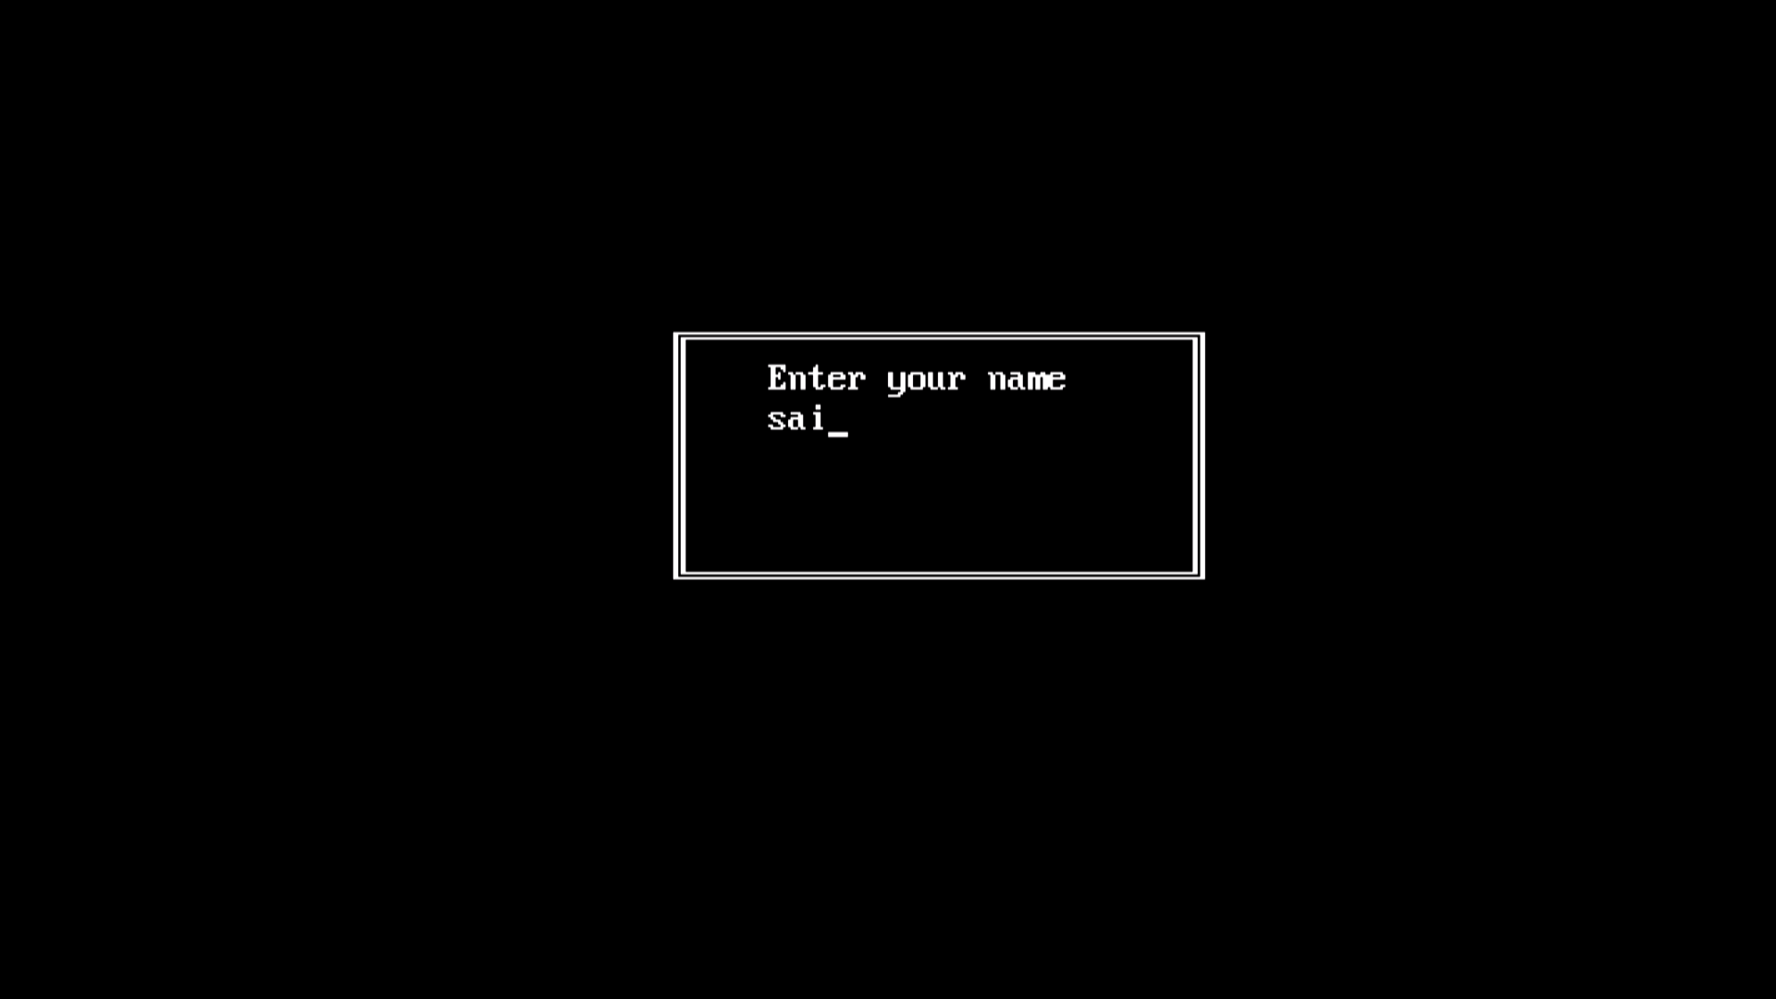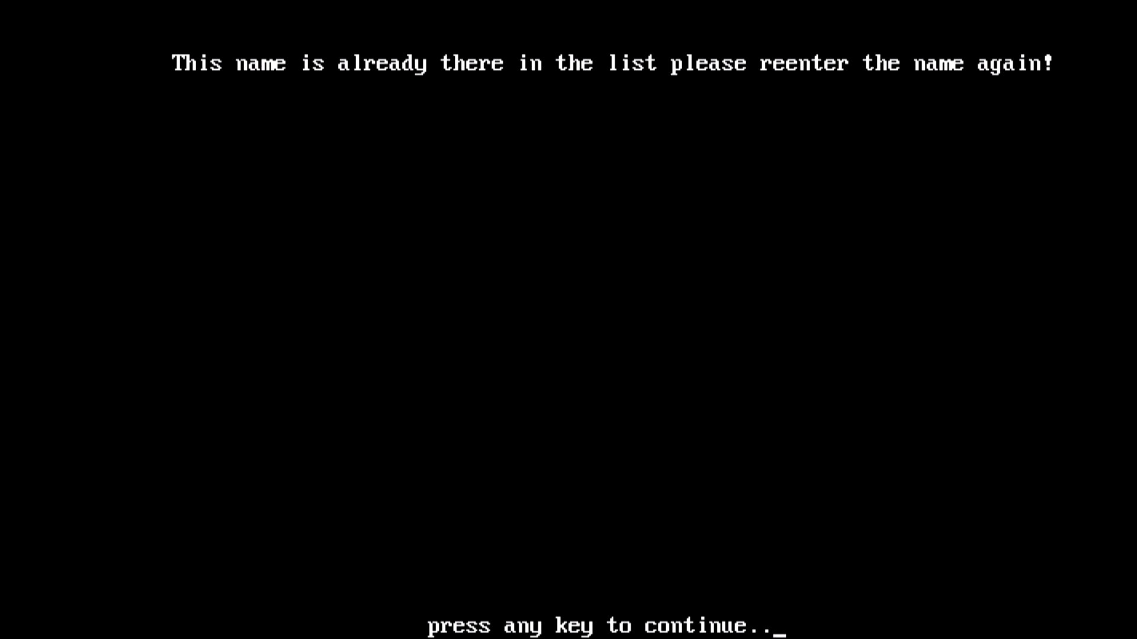

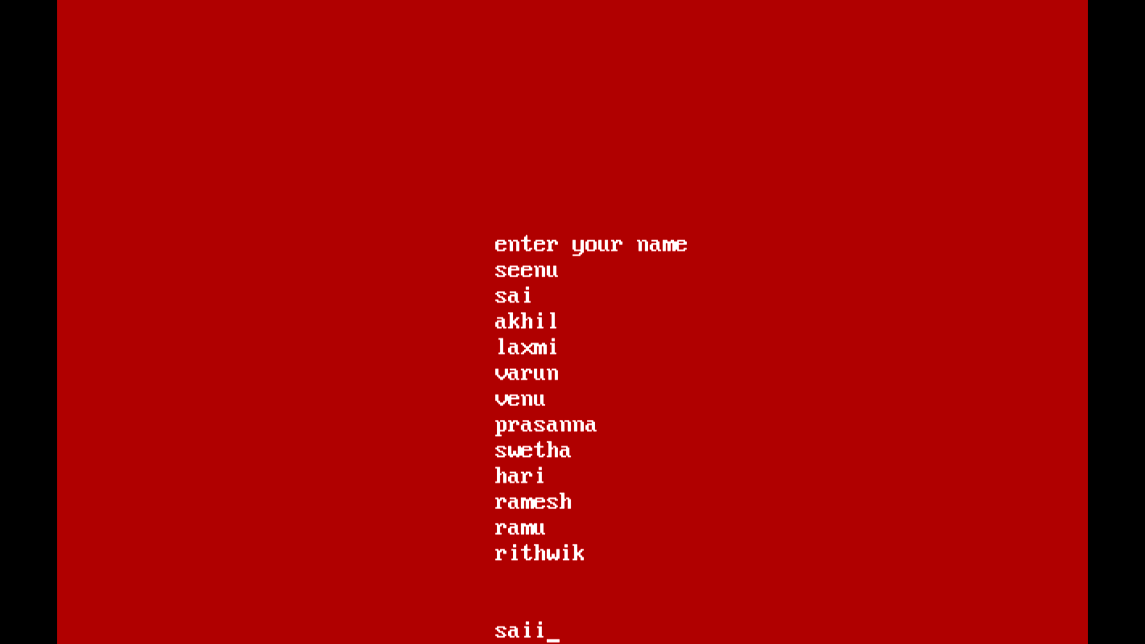

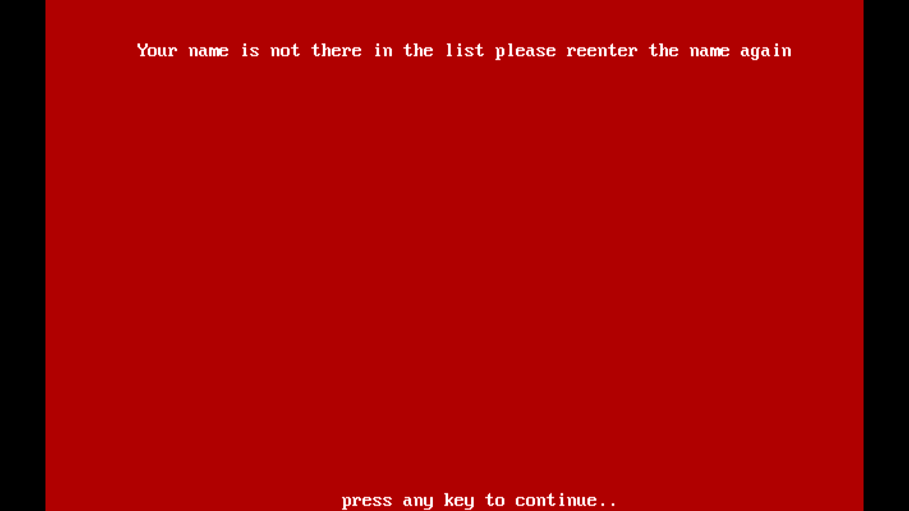

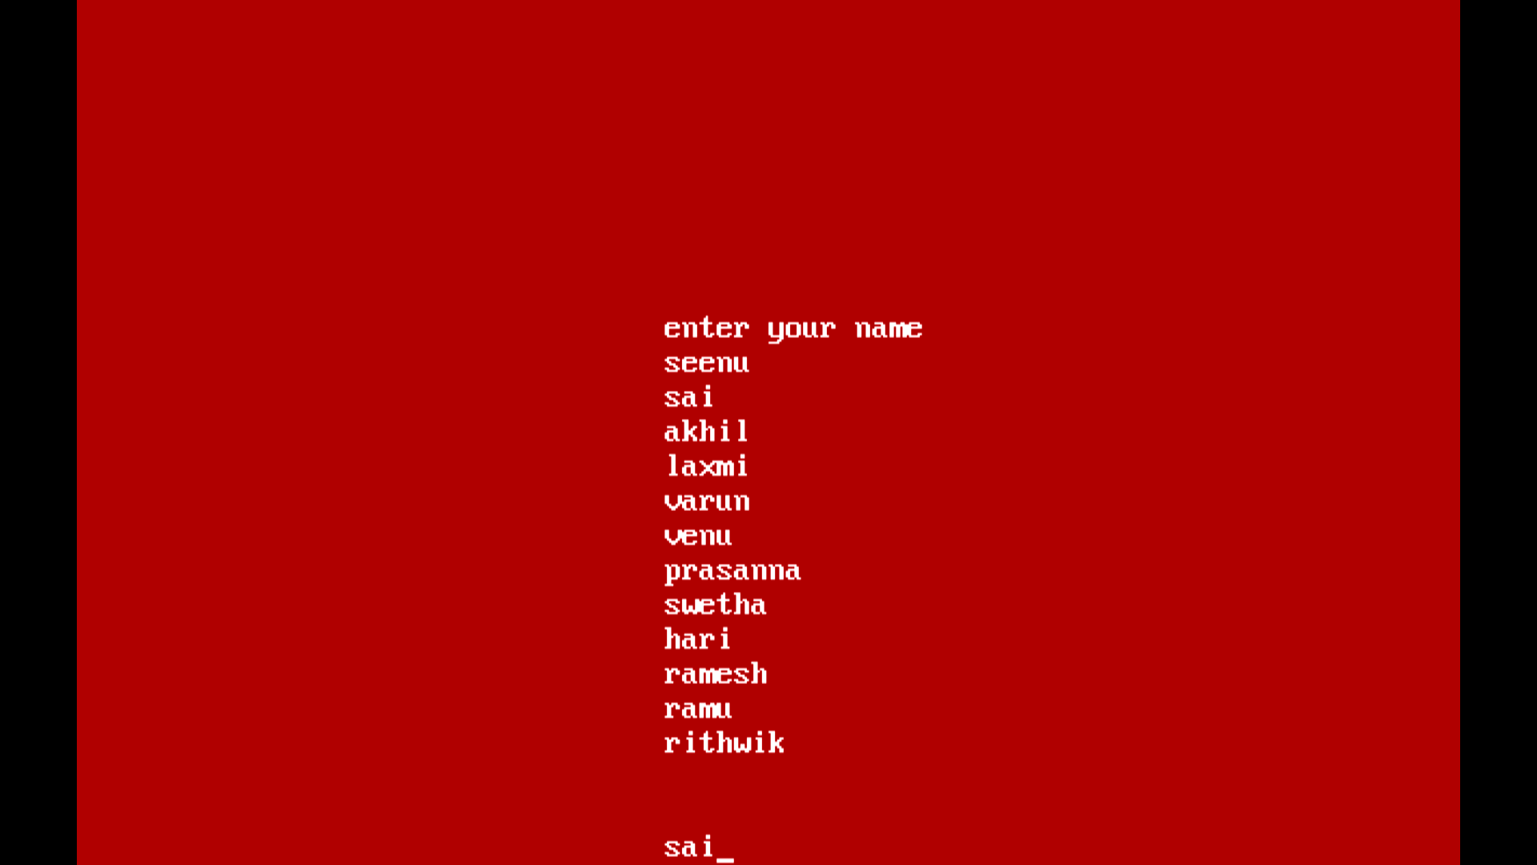

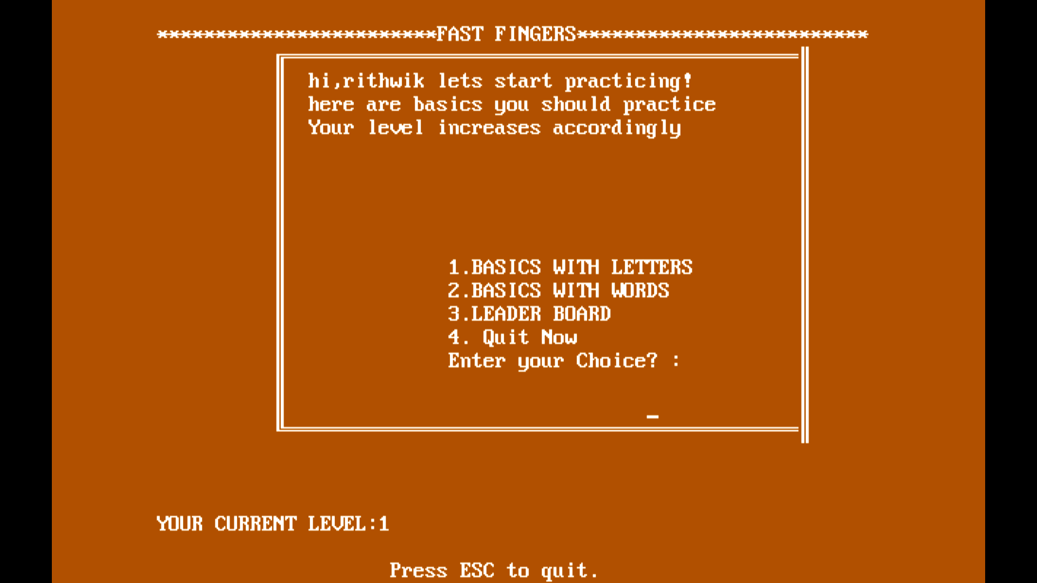

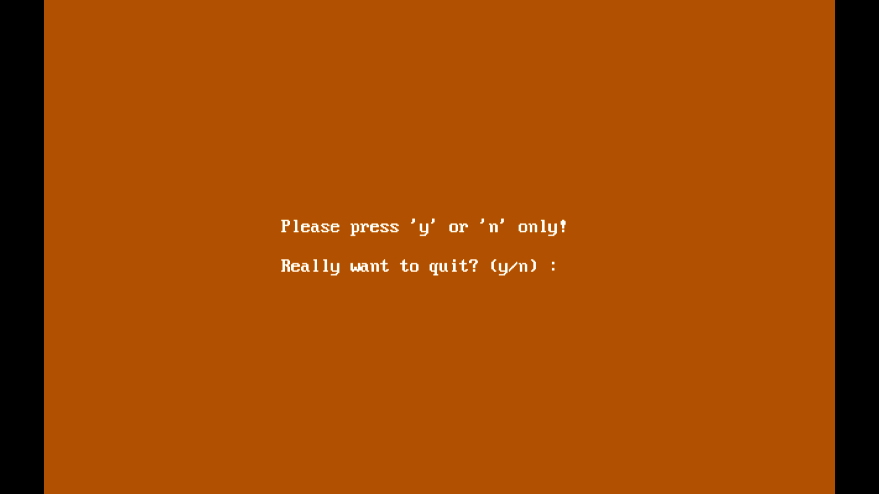

**RESULTS**



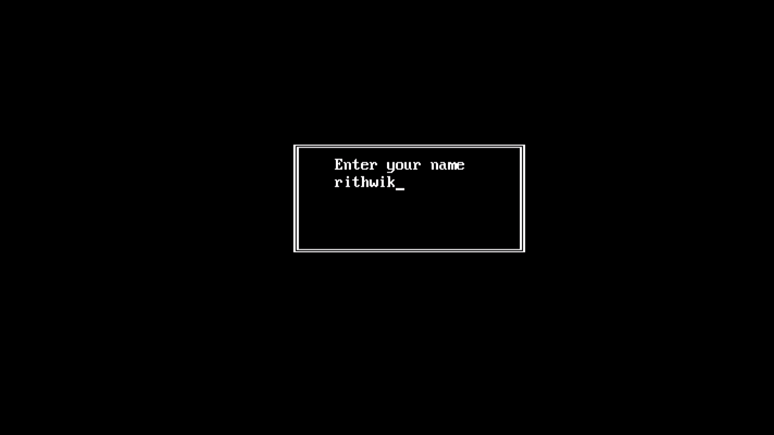



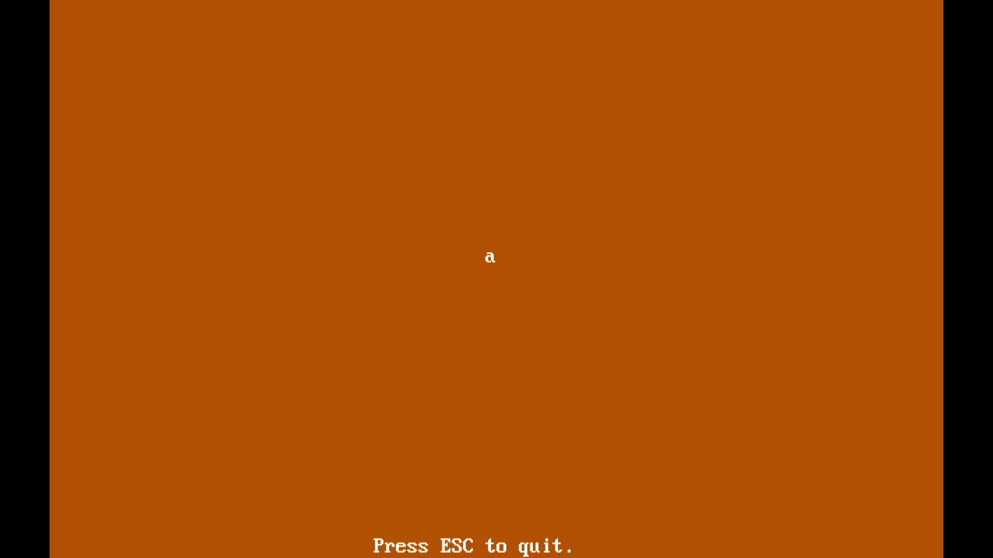

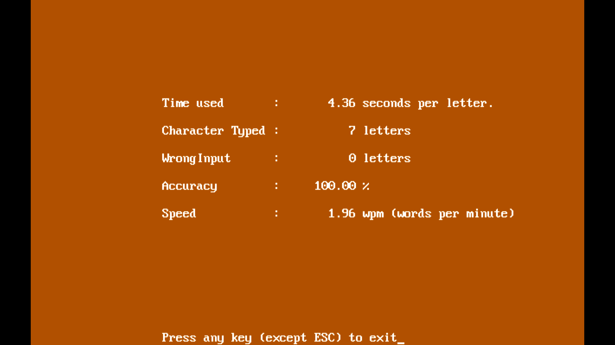

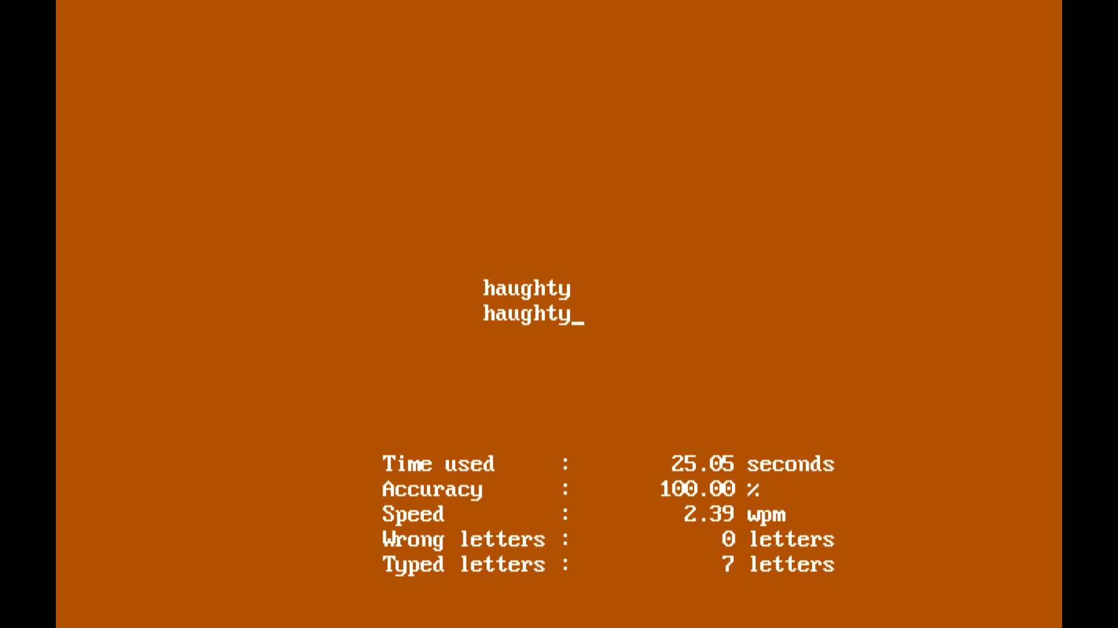

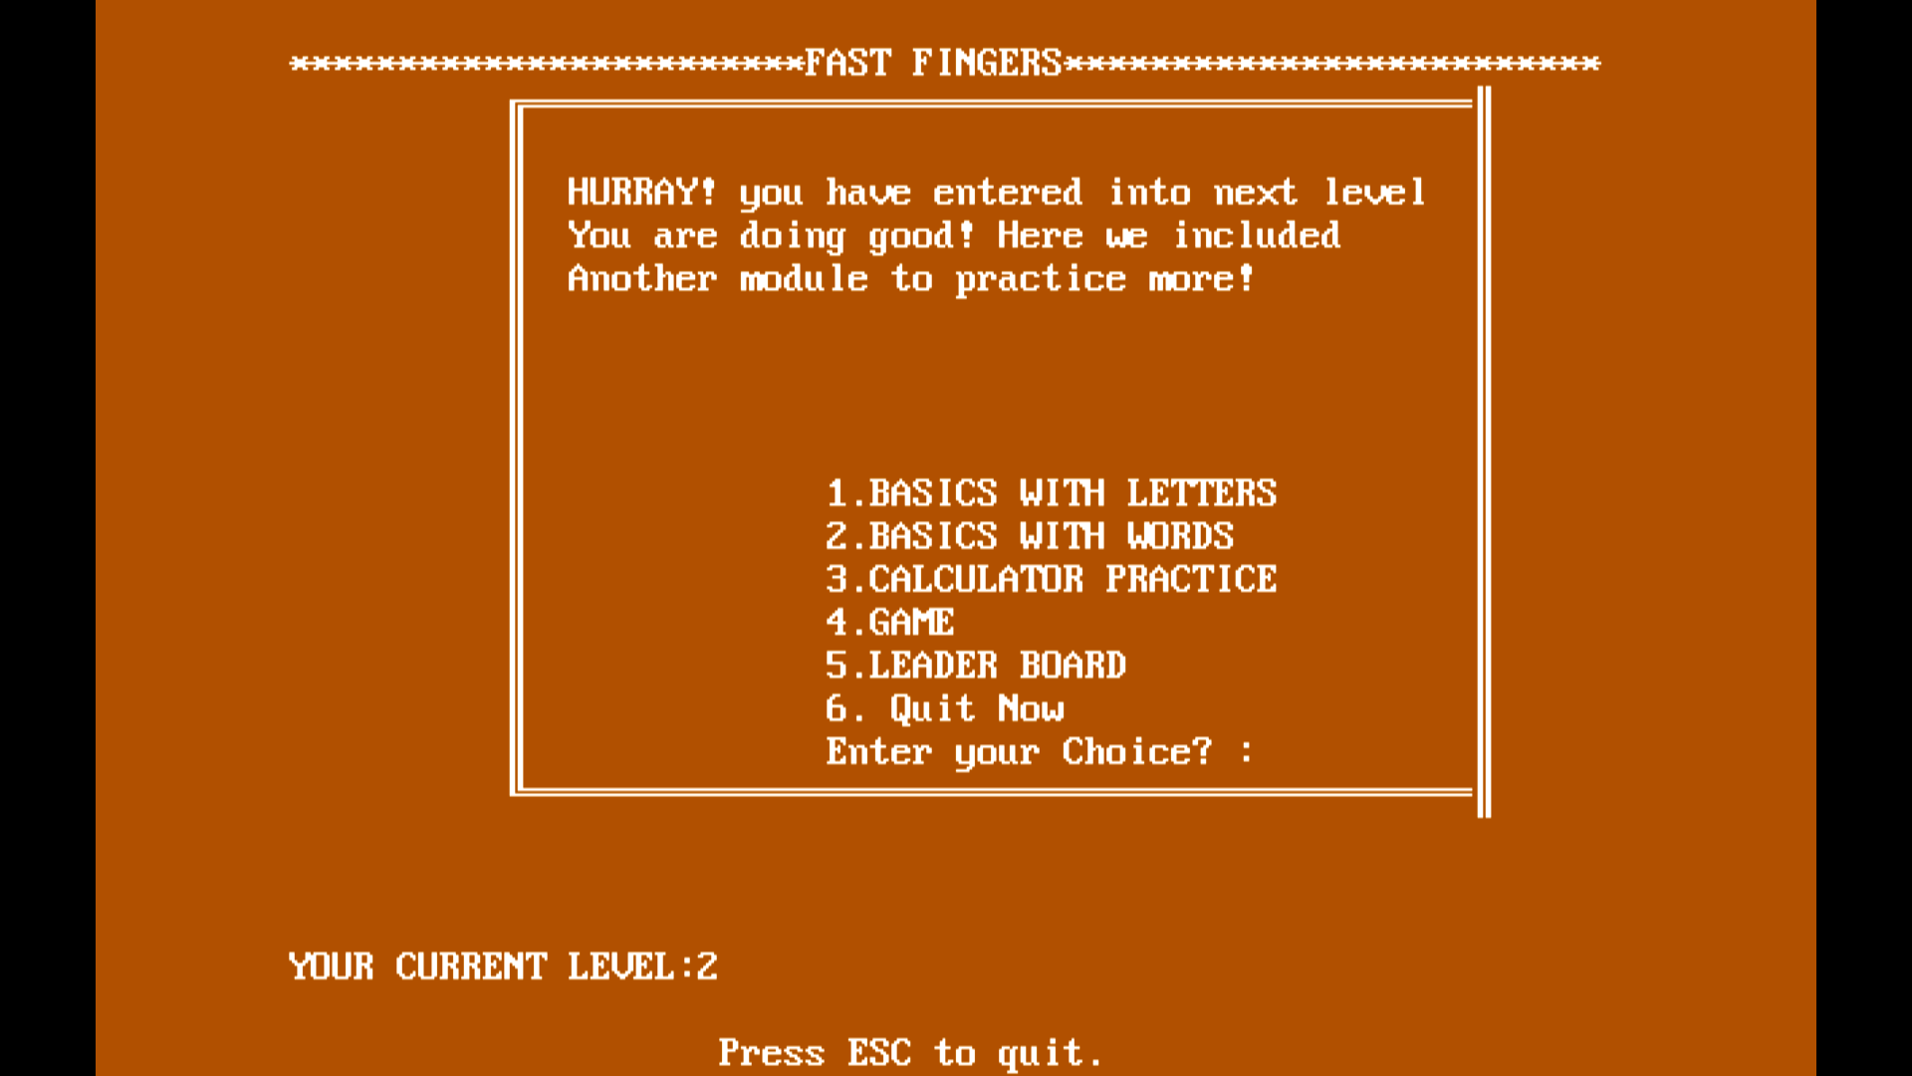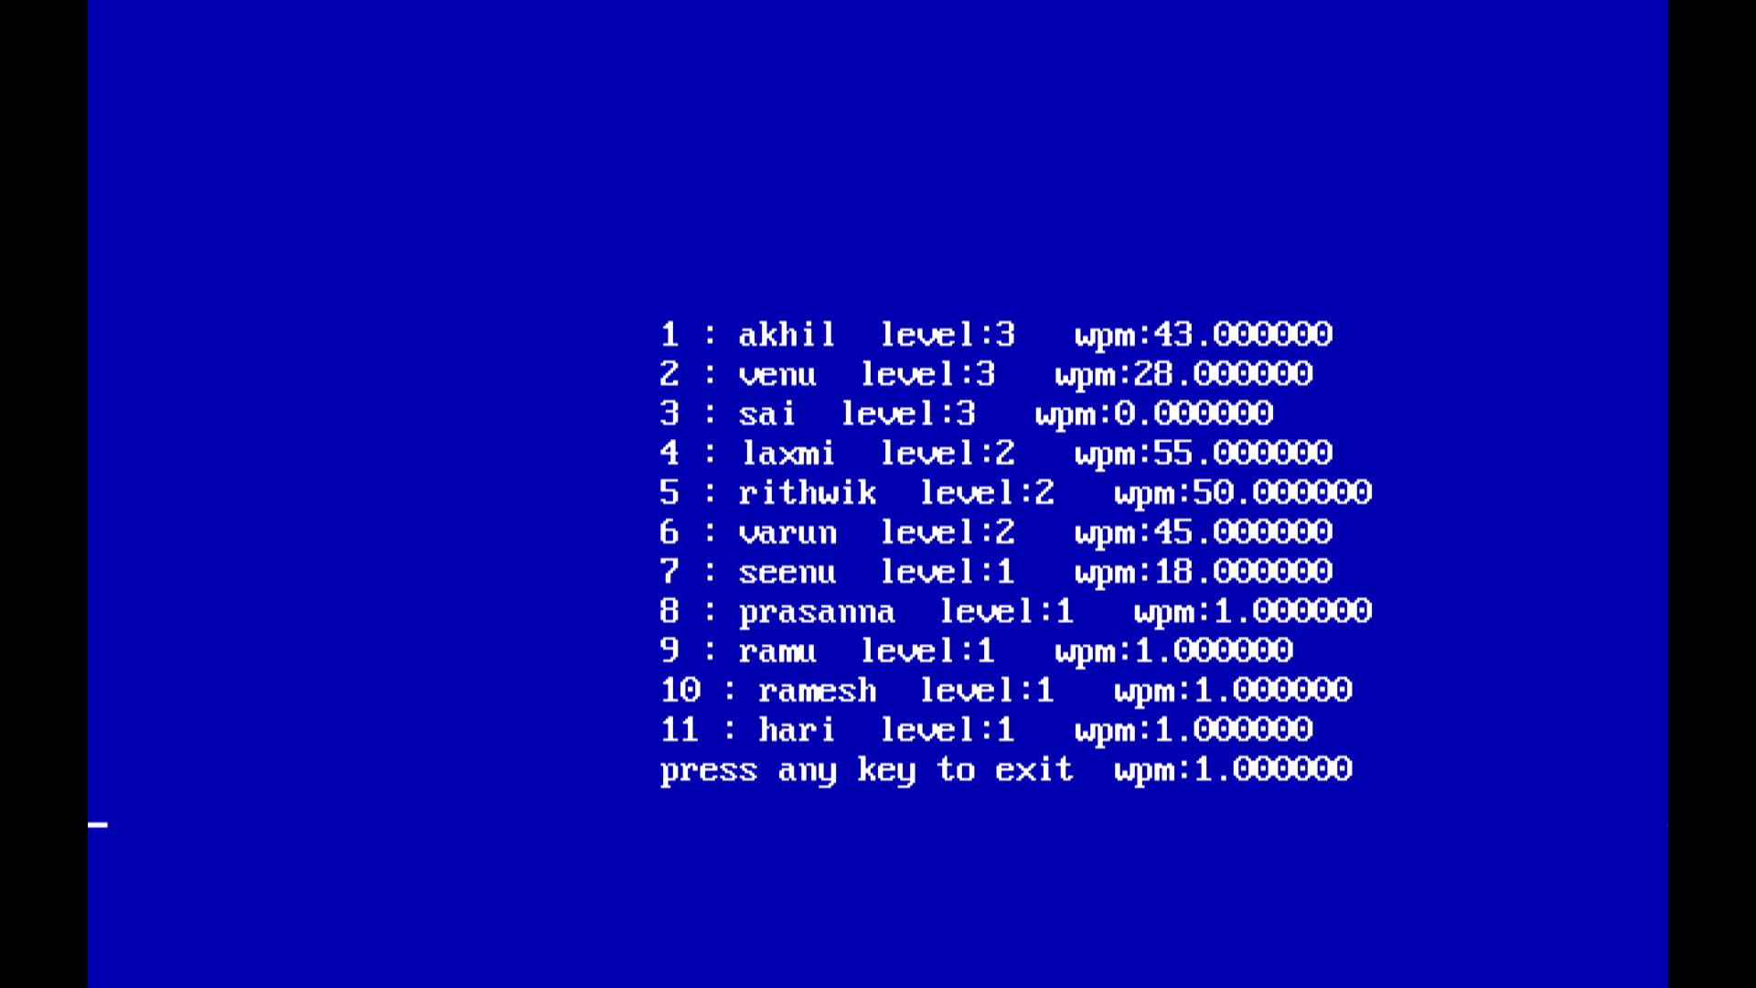

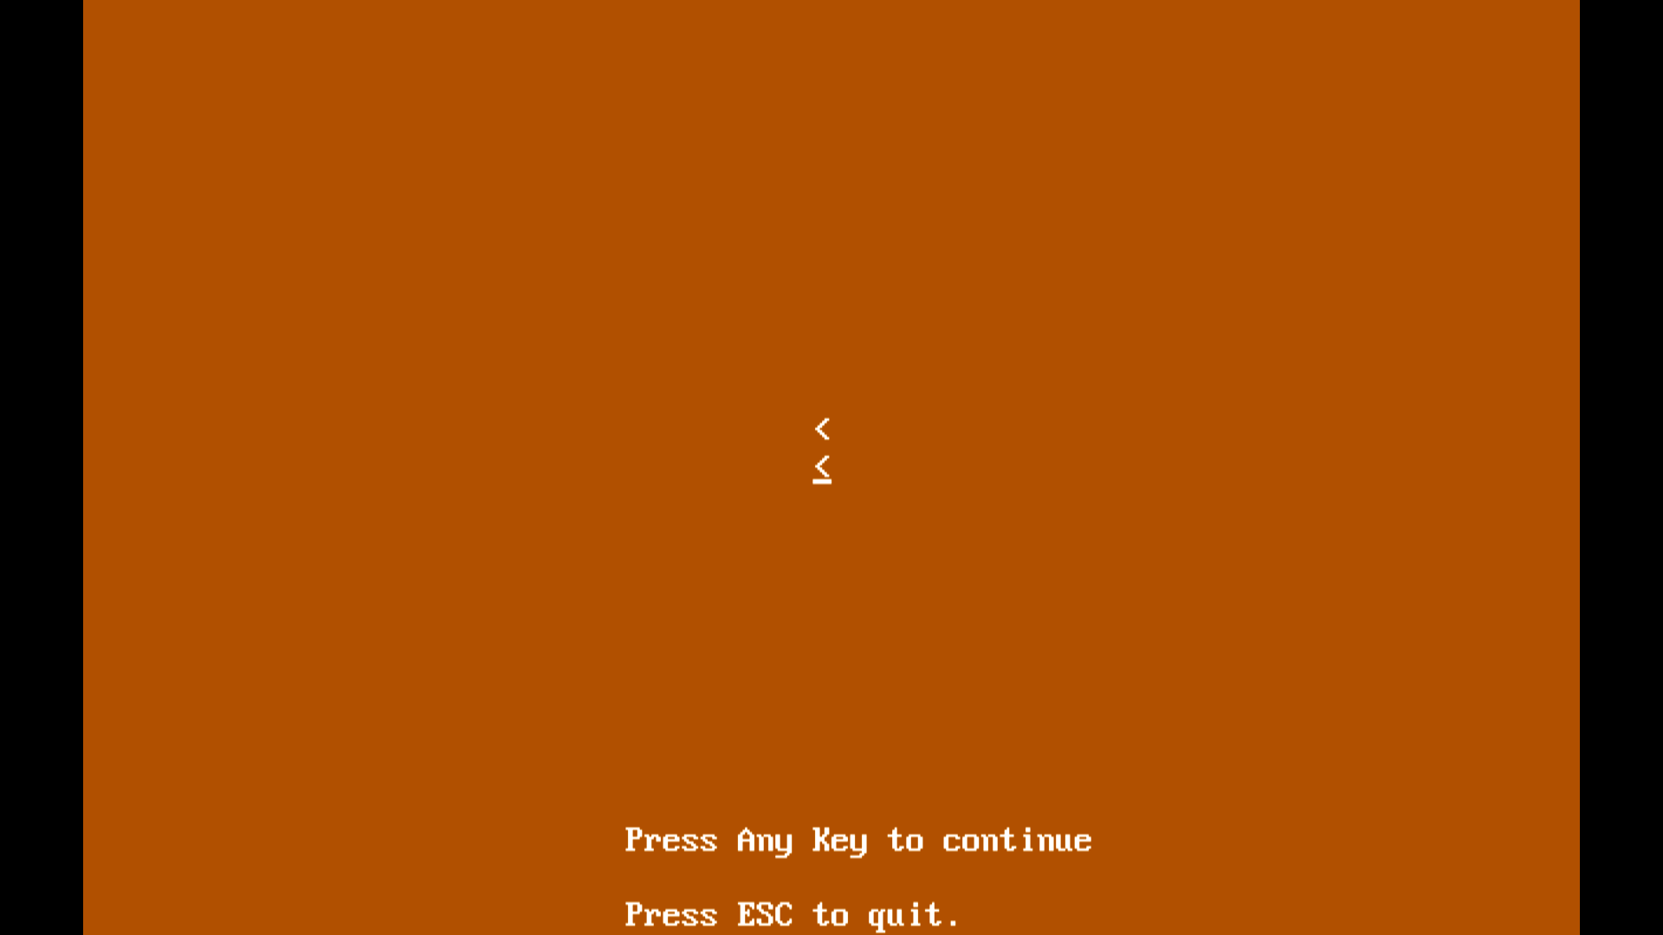

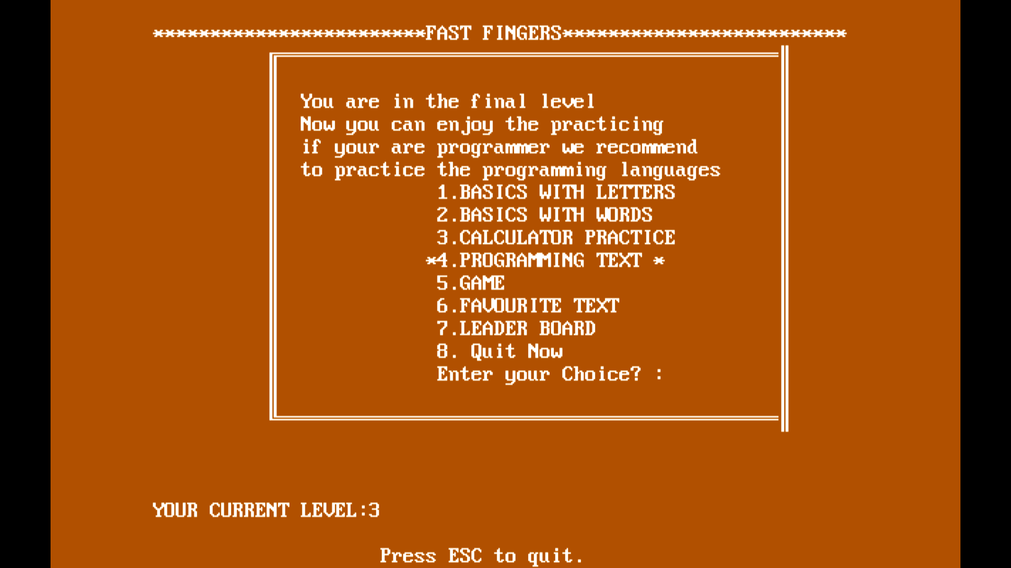

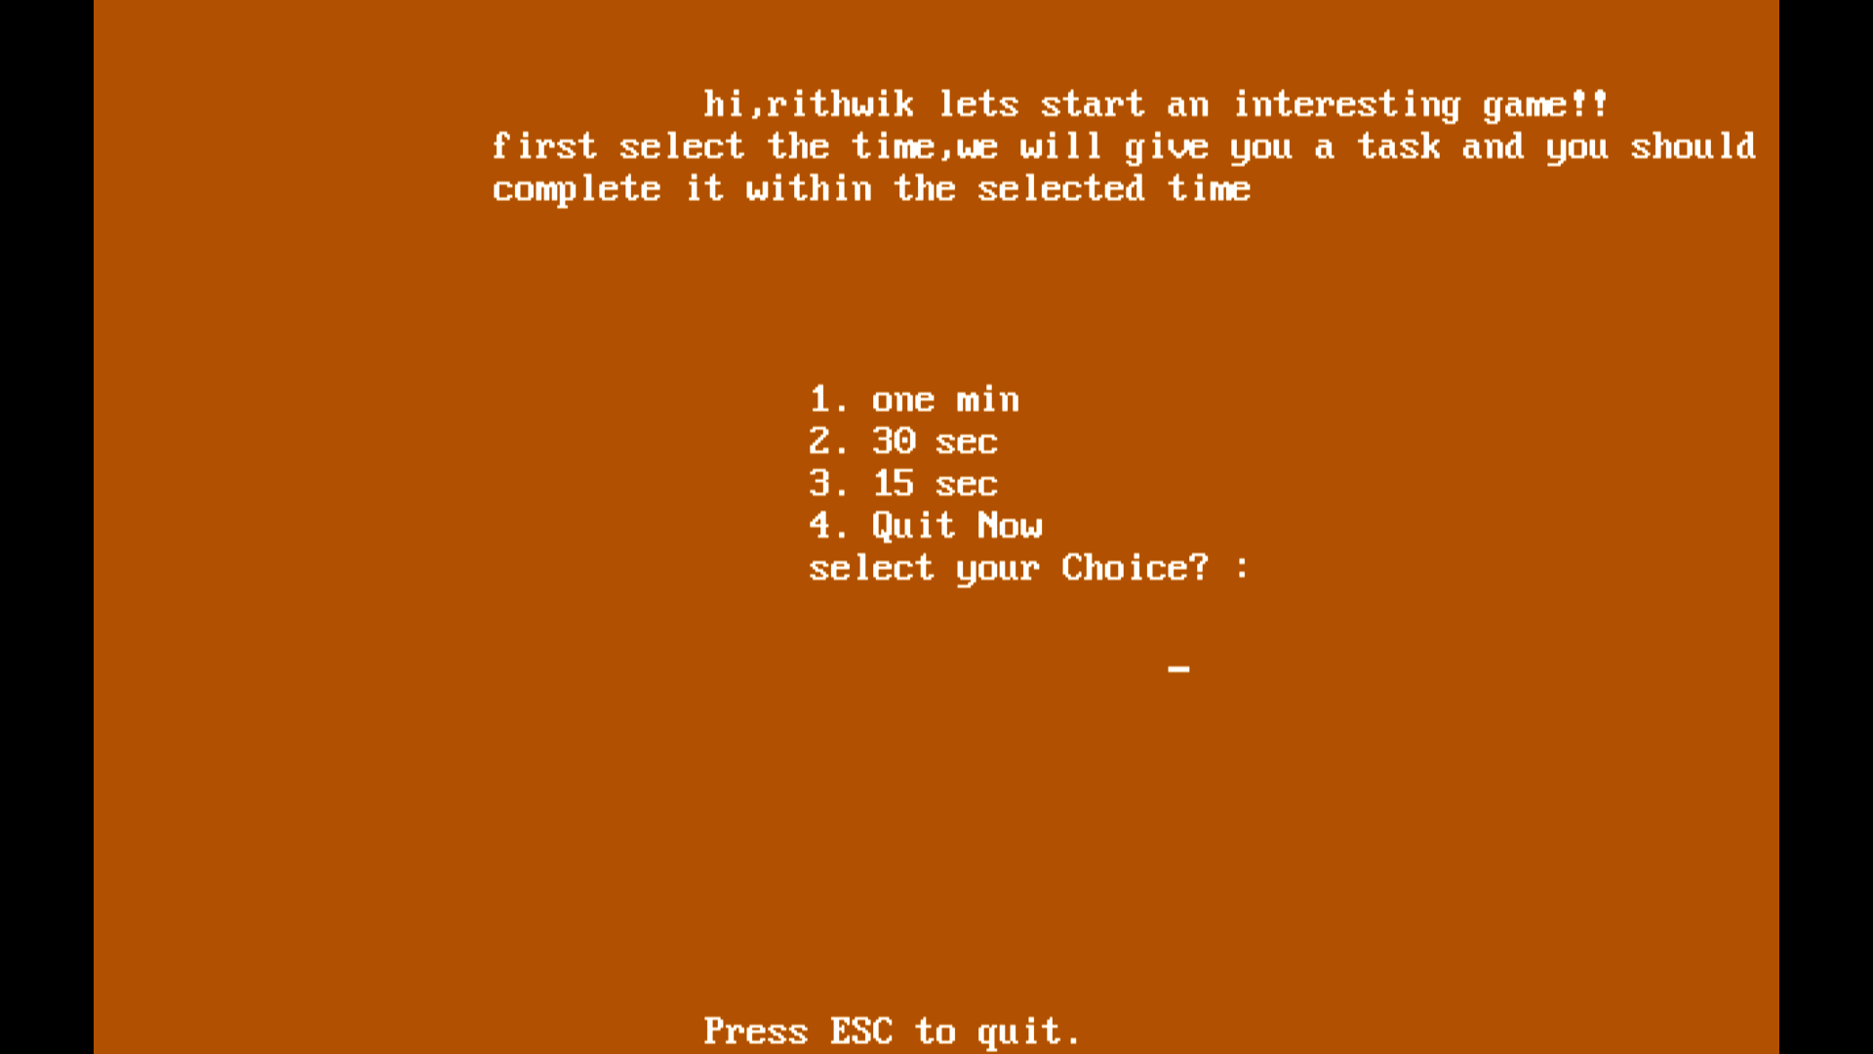

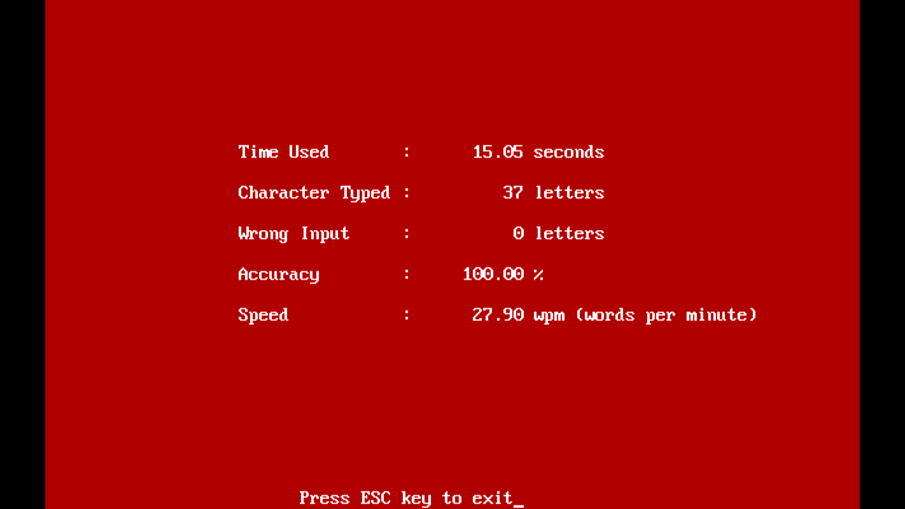

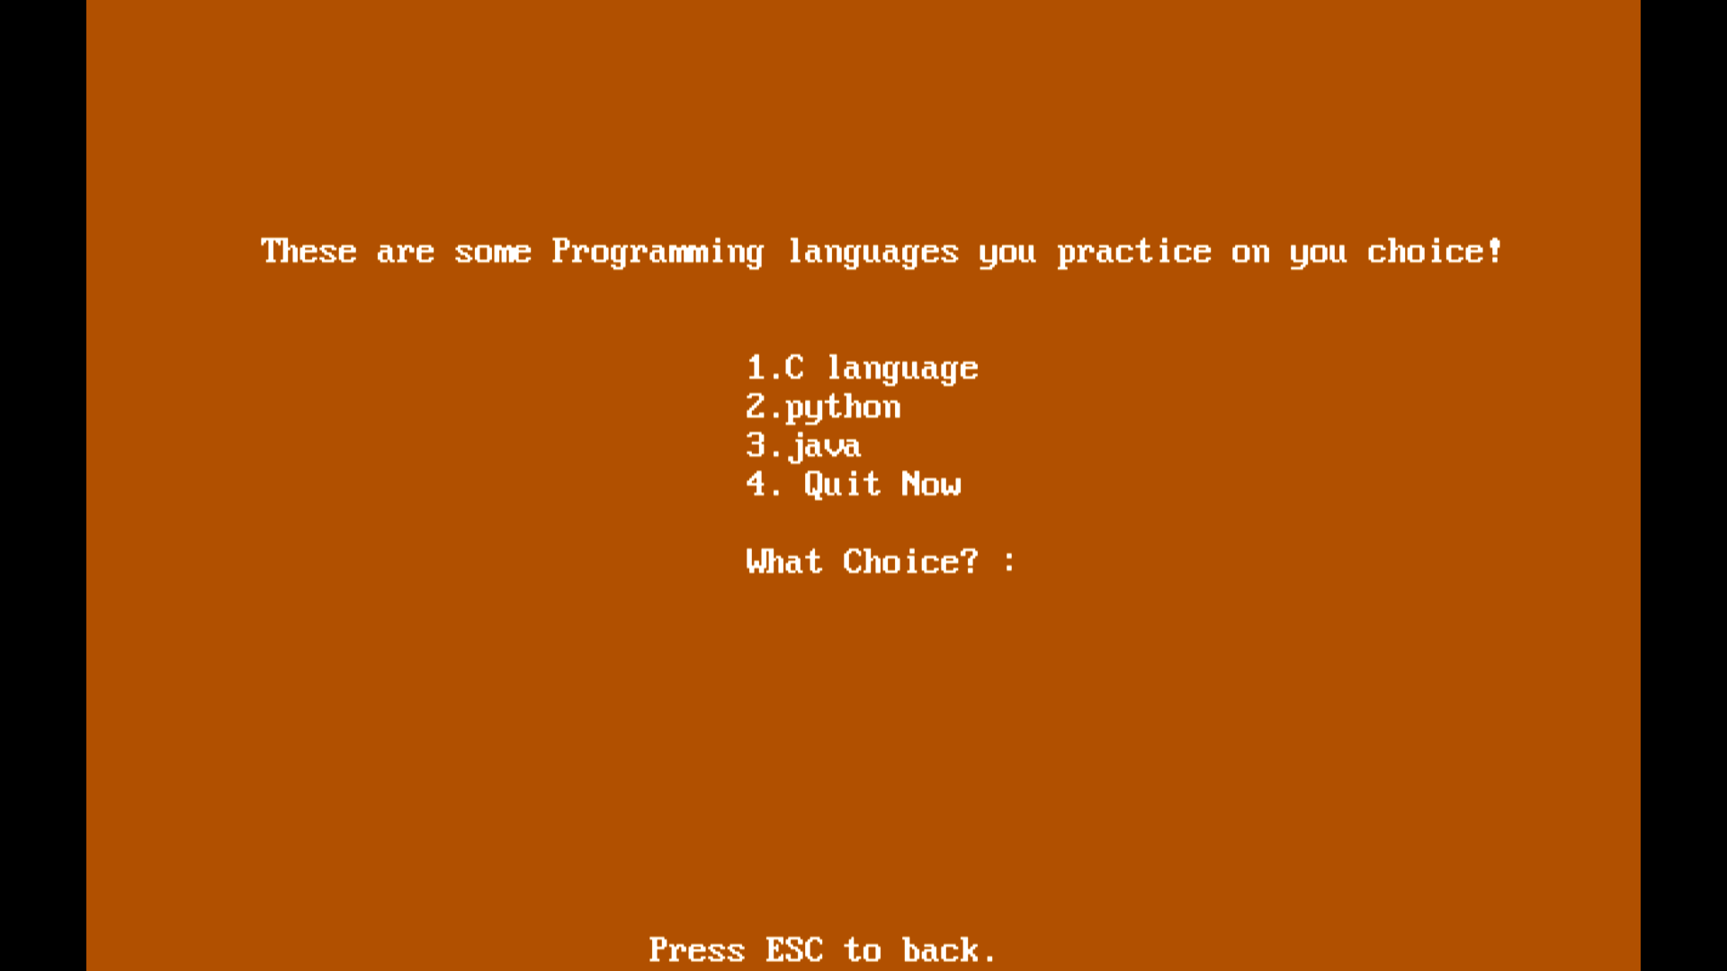

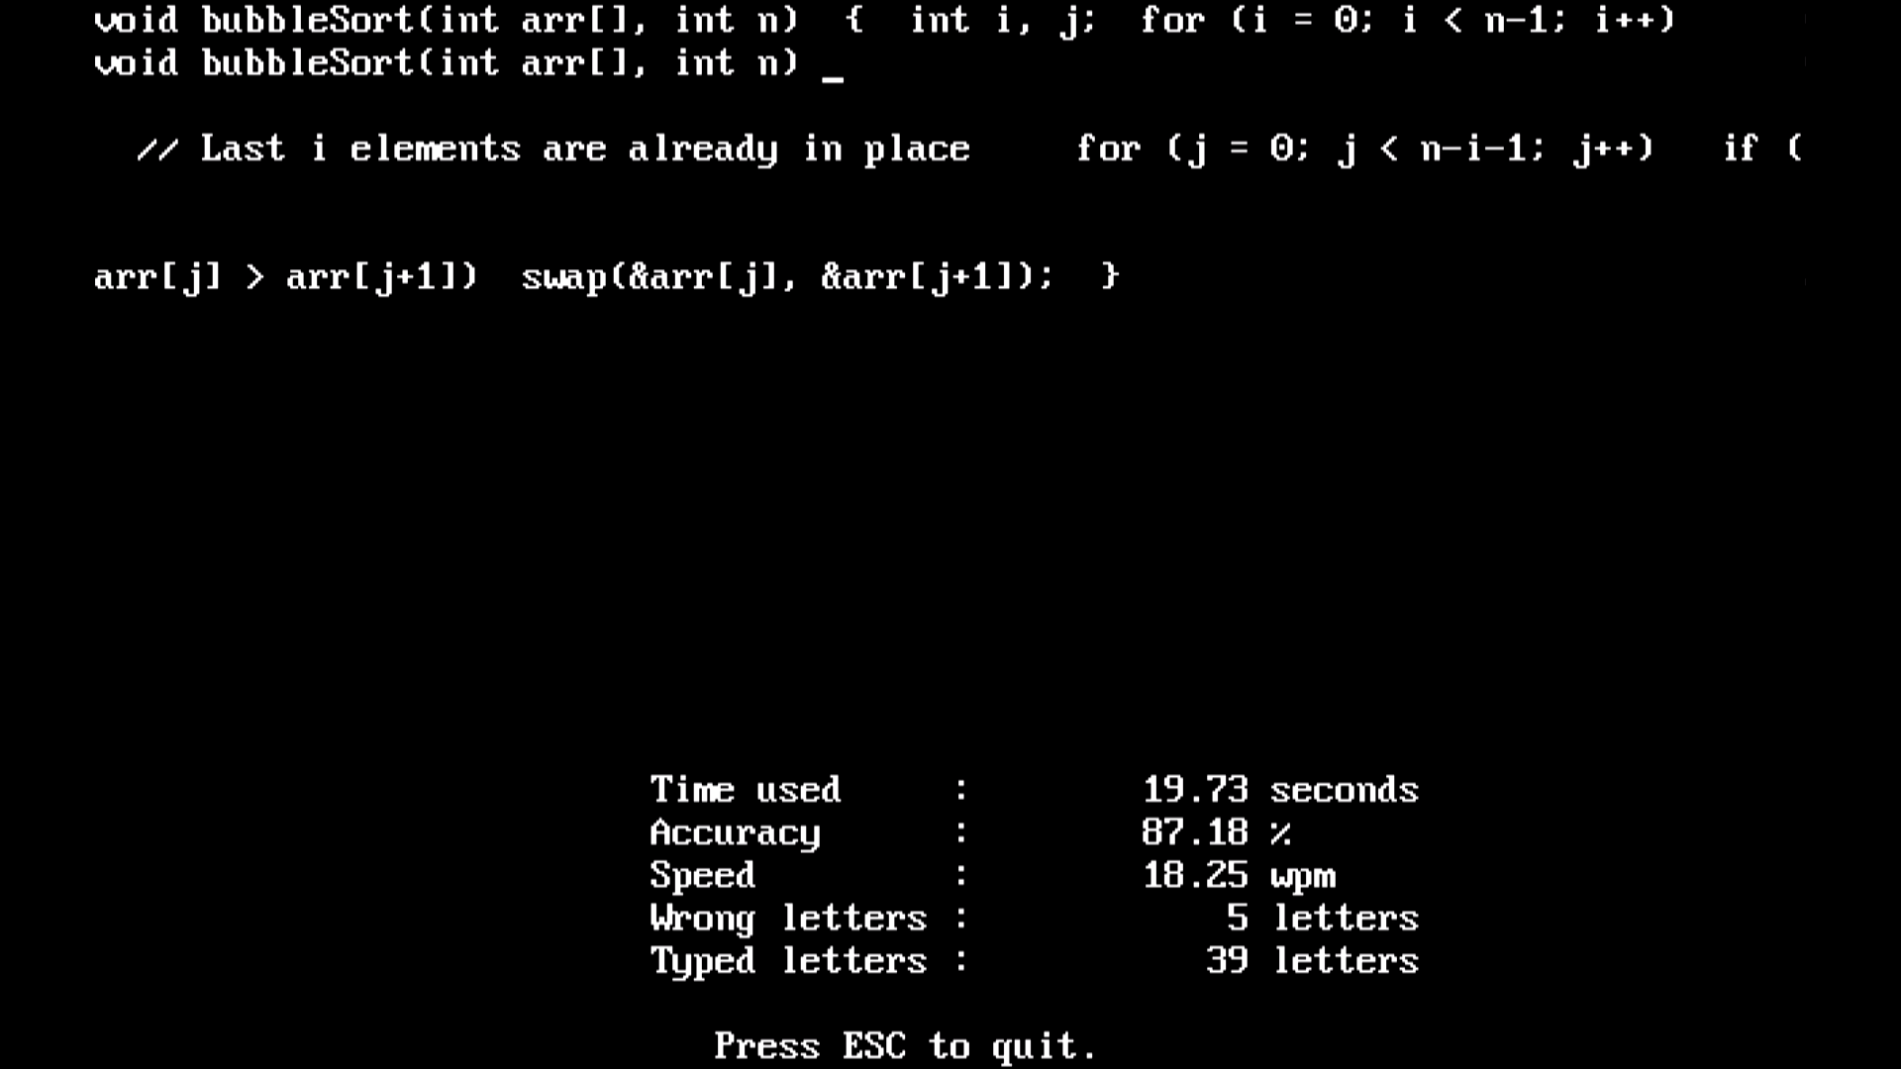

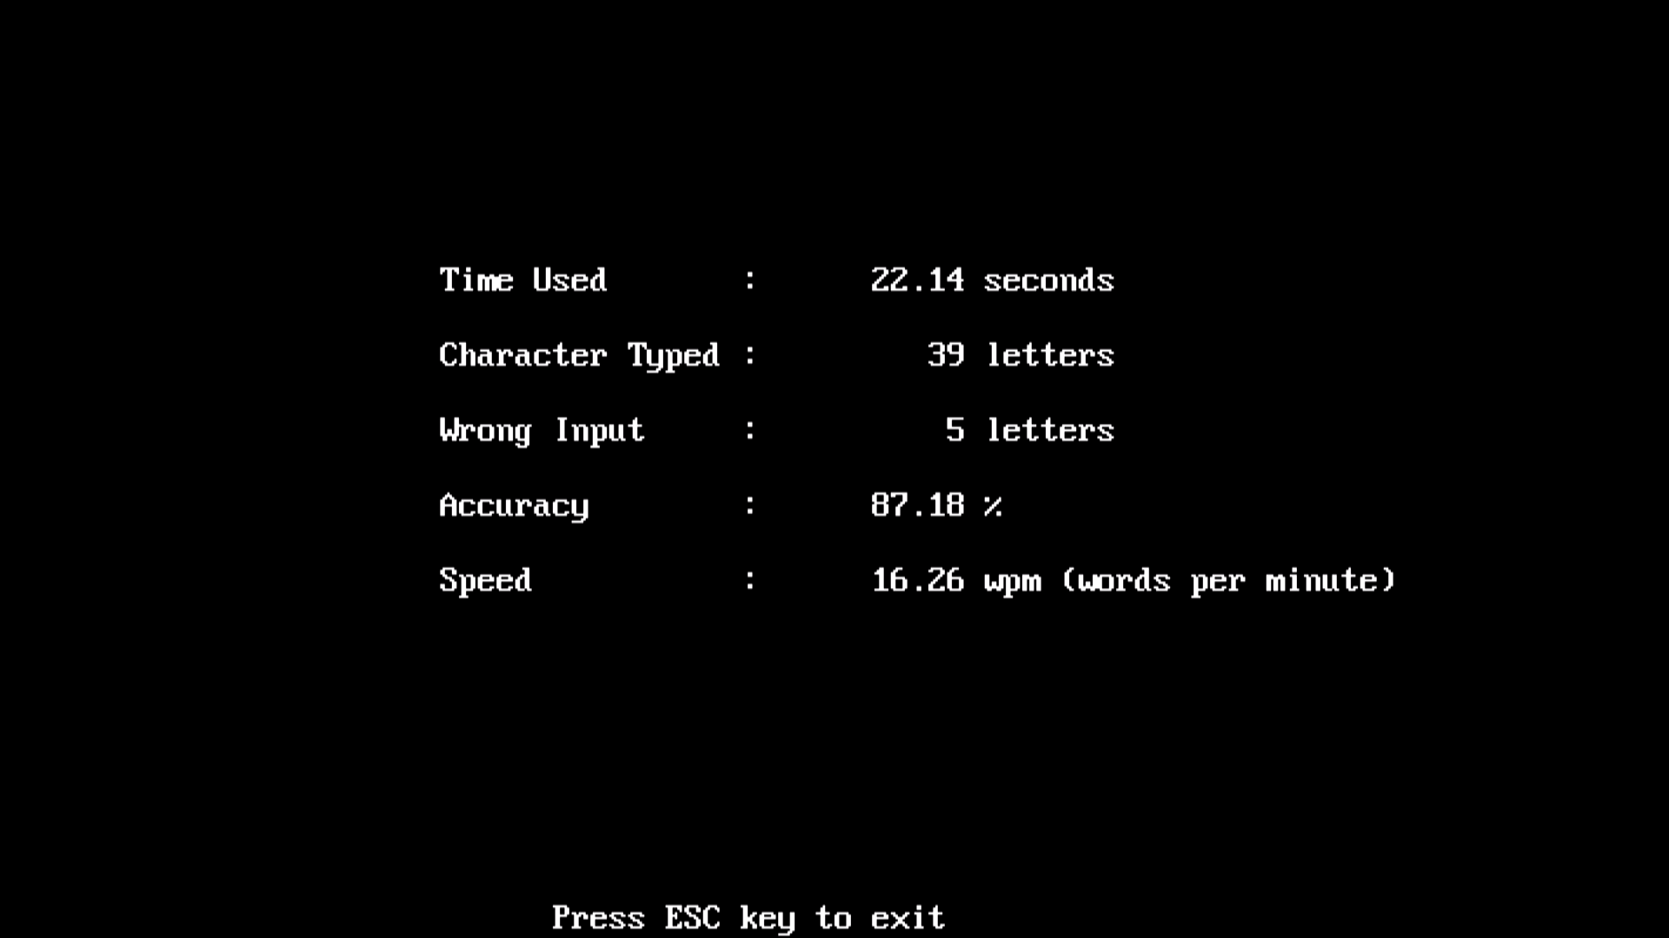

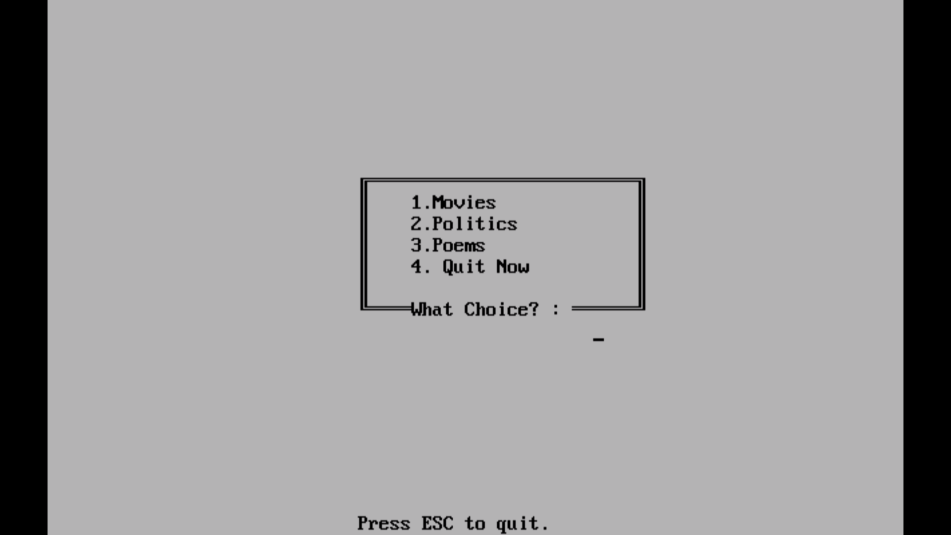

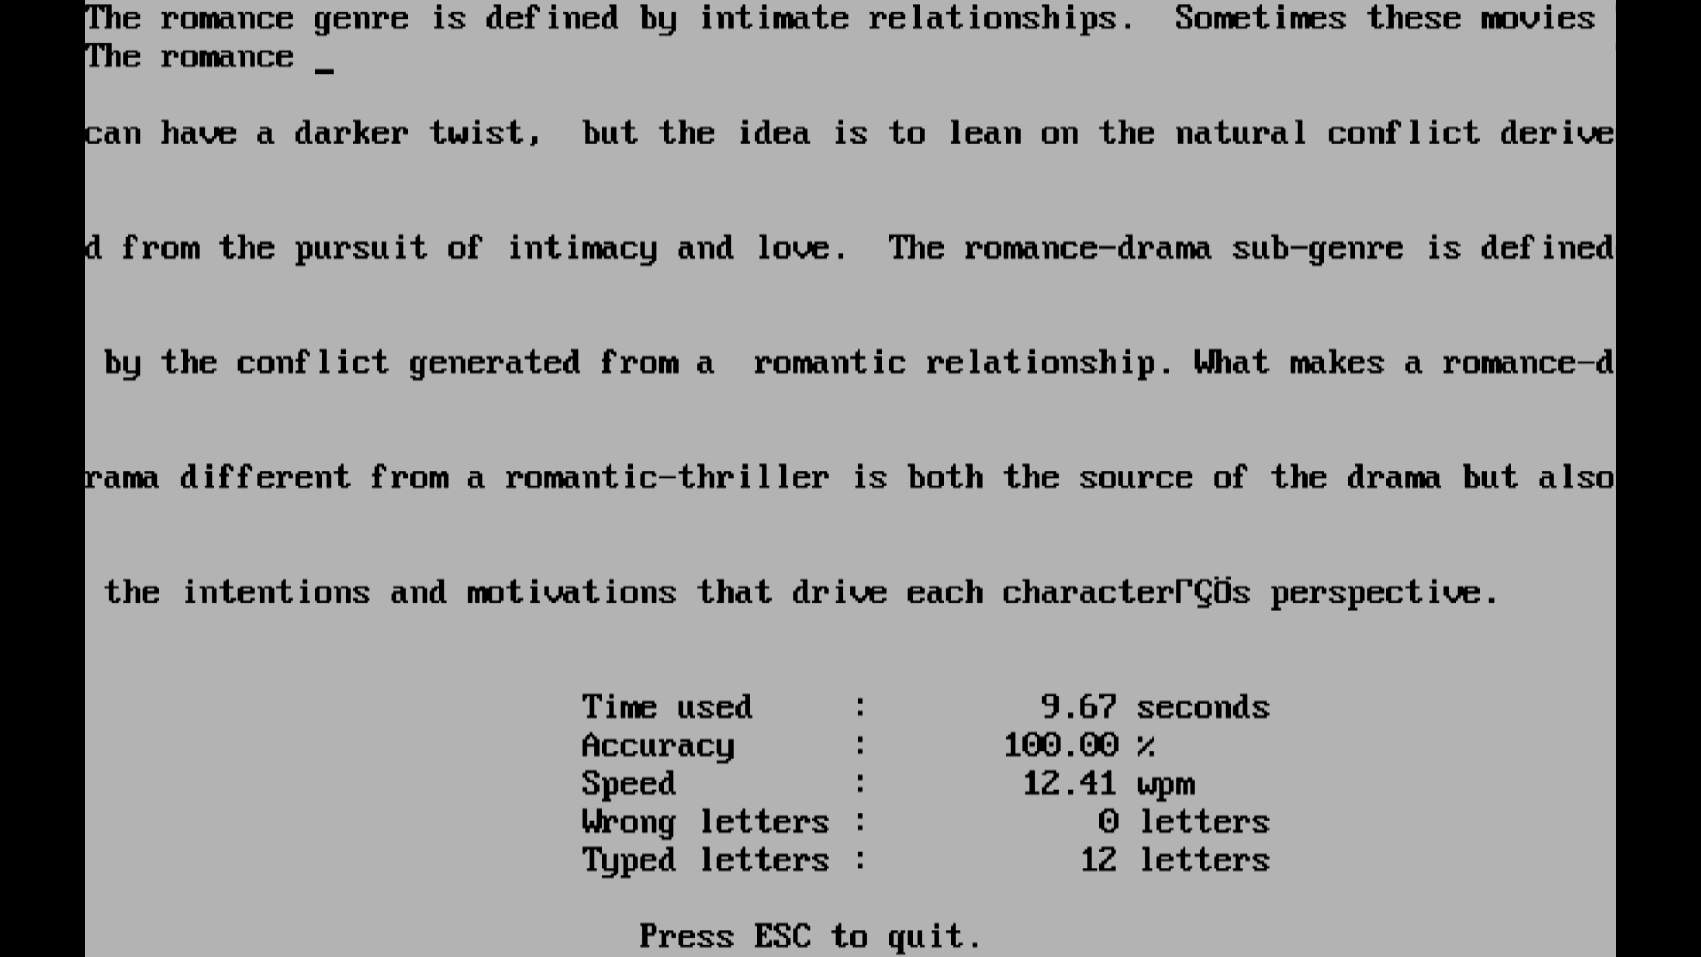

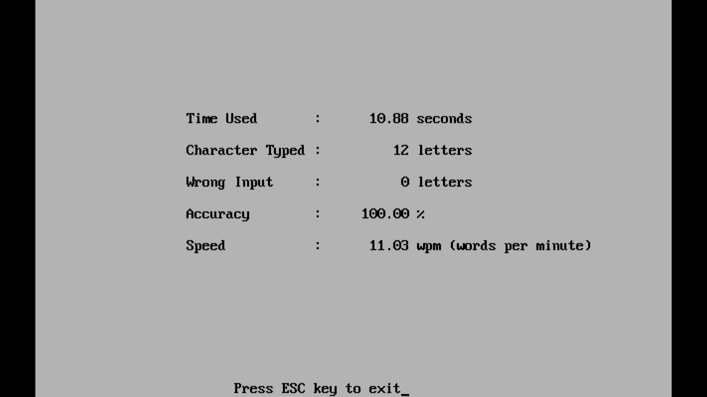

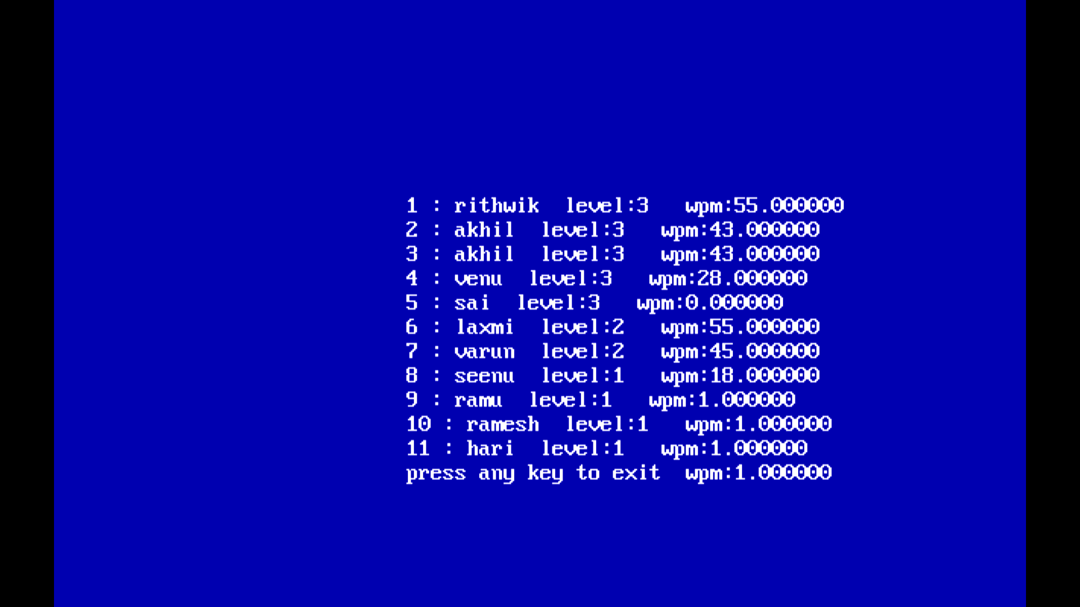

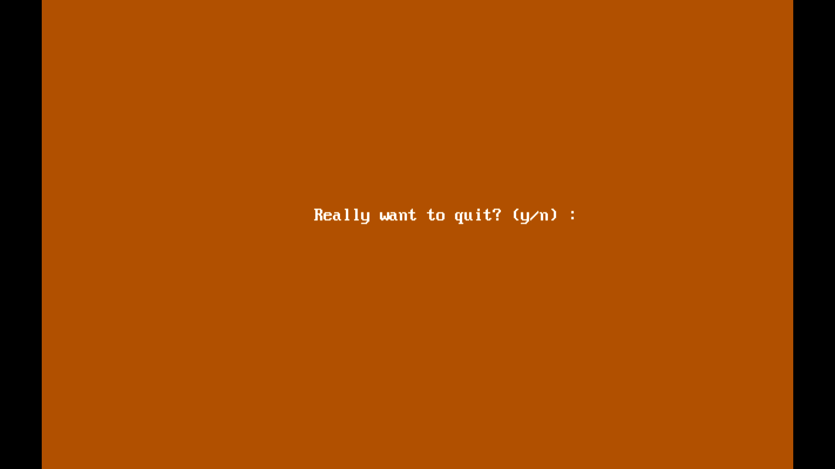

**ADDITIONALLY WHAT WE LEARNT**

This project helped us in gaining valuable information and practical knowledge on several topics like implementing files and use of different libraries in c which we are unaware of before, usage of responsive templates, designing logics for different use cases, and management of a huge program without any errors and thereby updating the outputs in a colourful way(mentioned in testing).

The entire system is secured as it is password based for a manager point of view . Also the project helped us understanding about the development phases of a project and software development life cycle. We learned how to test different features of a project. This project has given us great satisfaction in having designed an application which can be implemented to any nearby shops or branded shops selling various kinds of products by simple modifications .It was our own idea so implementing our thoughts and learning the different concepts was really a great experience . We have learnt how to handle the exceptions in the code and also came to know the different modules that can be implemented using the c language

Finally, we want to ensure that this project made us learn how to think of the logics and design them systematically.

**FUTURE WORK**

In future We can add more graphics, games with best gui’s so that user will get the best practise in touch typing

**REFERENCES**

[**https://www.geeksforgeeks.org/dos-h-header-in-c-with-examples/**](https://www.geeksforgeeks.org/dos-h-header-in-c-with-examples/)